# day 1 first scatter plot

weight=c(60, 65, 70, 72, 75)

height=c(170, 175, 168, 180, 178)

plot(weight, height, main="weight vs heigt",col="blue")

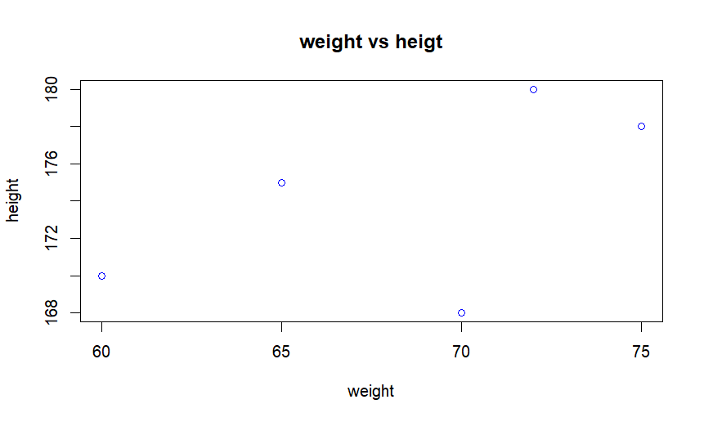

# day 1 second lines plot

year=c(2010, 2011, 2012, 2013, 2014)

population=c(1000, 1024, 1040, 1060, 1080)

plot(year, population, main= "year vs population")

lines(year, population,col="green")

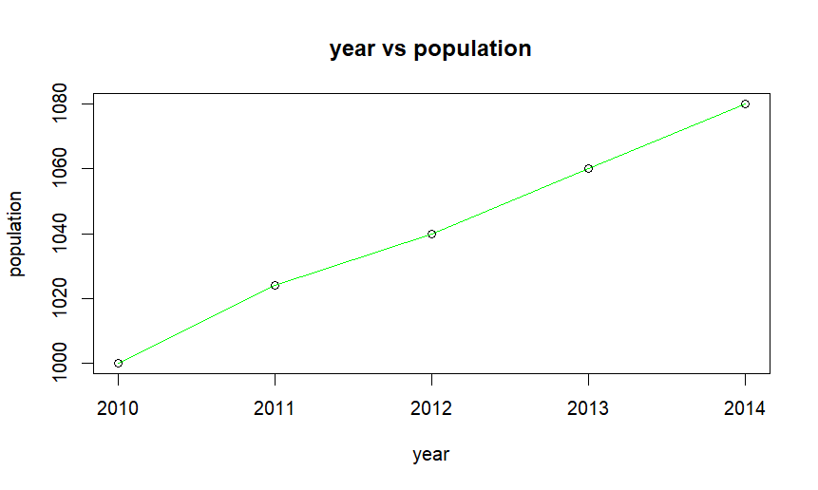

#day 1 third bar plot

product=c("a", "b", "c", "d", "e")

sales=c(300, 450, 500, 350, 400)

barplot(name.arg=product, sales, main="product vs sales ",col="violet")

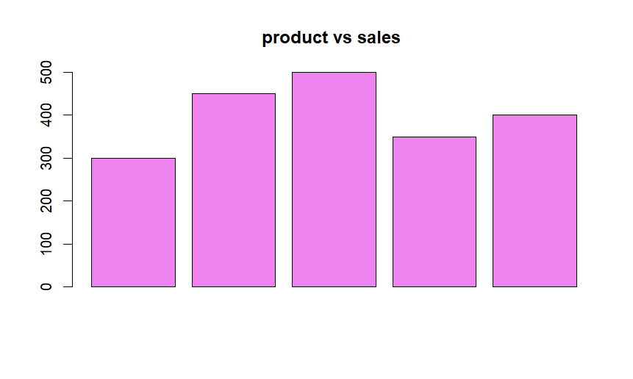

# day 1 fourth histogram

age=c(25, 30, 35, 40, 45, 50, 55, 60, 65, 70)

hist(age,main="age",col="darkgreen",xlab="frequency",ylab="age",breaks= 10)

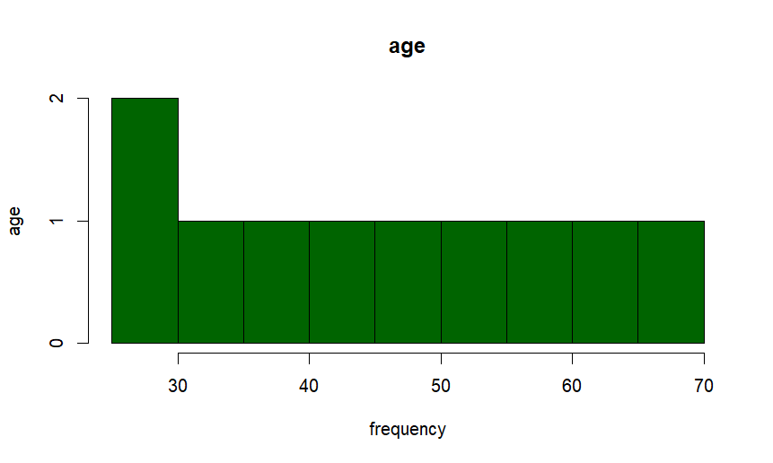

# day 1 fifth pie chart

company=c("a", "b", "c", "d")

market=c(20,30,25,25)

pie(market,labels=company,main="market share by company",col=rainbow(length(company)))

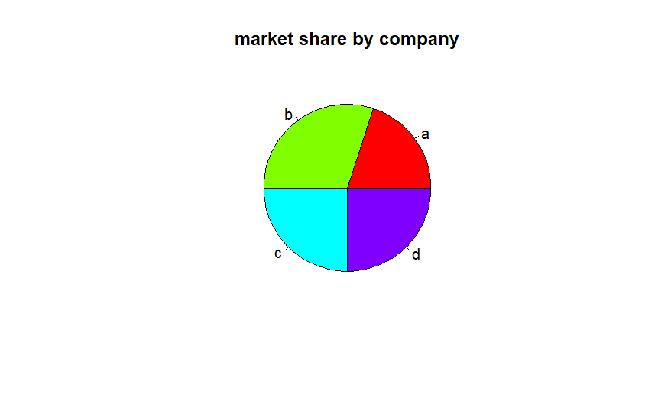

#day 1 sixth box plot

class <- c("A", "A", "A", "A", "B", "B", "B", "B")

scores <- c(85, 90, 78, 92, 88, 76, 80, 84)

boxplot(scores ~ class, main = "Scores by Class", xlab = "Class", ylab = "Scores", col = c("blue", "lightgreen"))

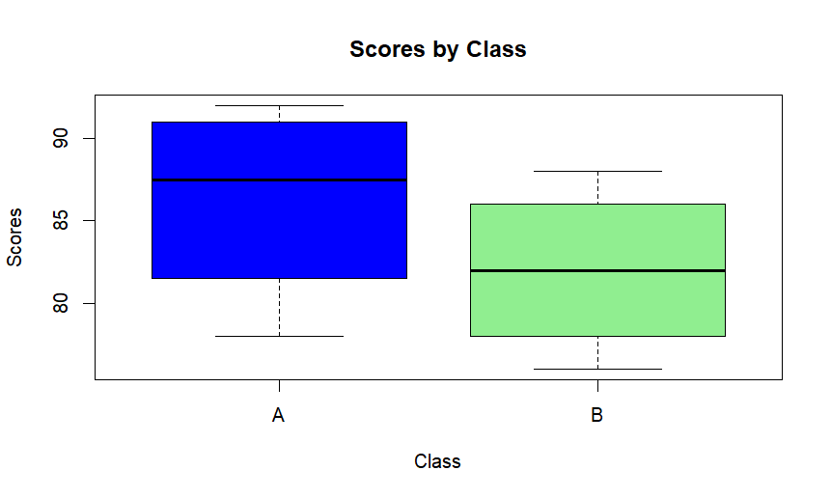

#day 1 seventh density plot

weight <- c(60, 65, 70, 75, 80, 85, 90, 95, 100)

boxplot(weight, main = "Weight Distribution", ylab = "Weight (kg)", col = "purple")

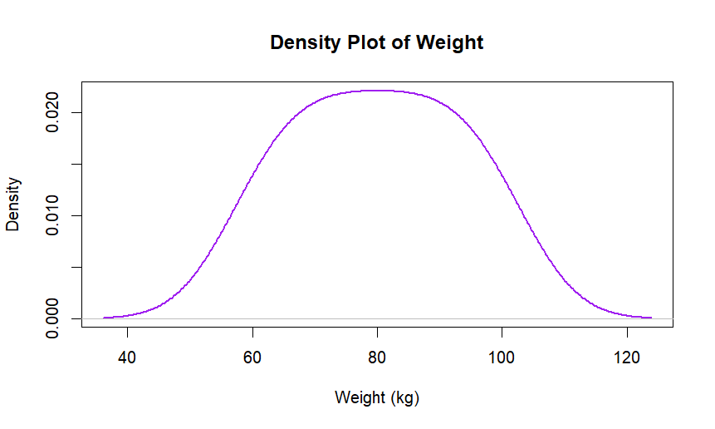

#day 1 eighth violin plot

library(vioplot)

Group <- c("X", "X", "X", "X", "Y", "Y", "Y", "Y")

Score <- c(80, 85, 78, 92, 88, 76, 80, 84)

vioplot(Score[Group == "X"], Score[Group == "Y"],

names = c("Group X", "Group Y"),

col = c("orange", "yellow"),

main = "Violin Plot of Scores by Group",

xlab = "Group",ylab="Score")

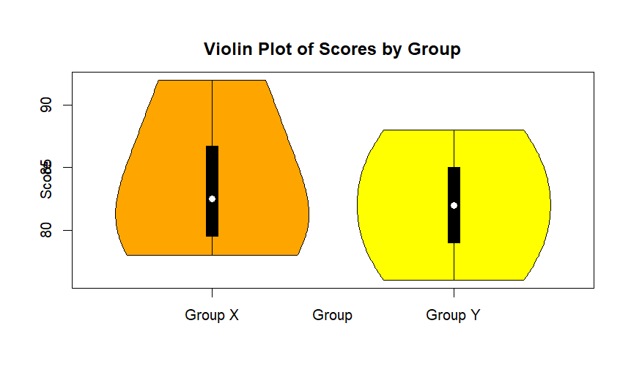

#day 1 nineth

temperature_data <- data.frame(

Month = c("Jan", "Feb", "Mar", "Apr", "May"),

city_a = c(5, 6, 7, 8, 9),

city_b = c(10, 11, 12, 13, 14),

city_c = c(15, 16, 17, 18, 19)

)

rownames(temperature_data) <- temperature_data$Month

temperature_data <- temperature_data[, -1]

heatmap(as.matrix(temperature_data),

main = "Temperature Heatmap",

xlab = "Cities", ylab = "Months",

col = heat.colors(256), scale = "column",

margins = c(5, 10),

cexRow = 1.2,

cexCol = 1.2,

las=2)

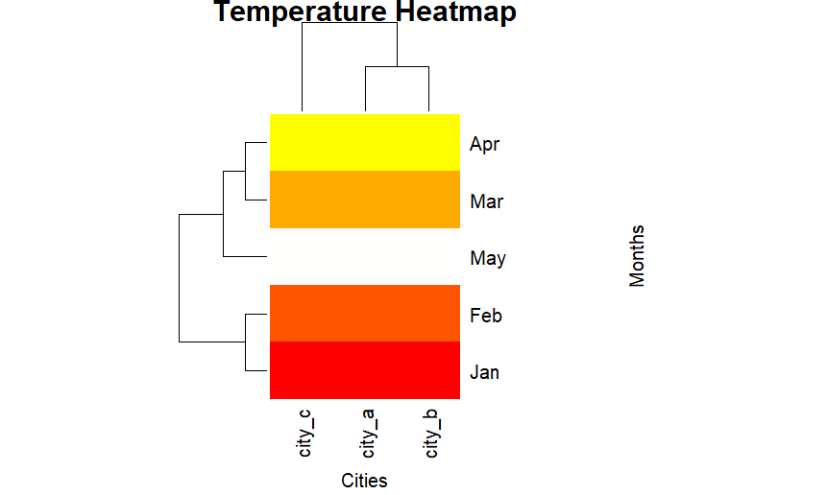

#day 1 tenth

Sales_data <- data.frame(

Month = c("Jan", "Jan", "Feb", "Feb", "Mar", "Mar"),

Region = c("East", "West", "East", "West", "East", "West"),

Sales = c(200, 150, 220, 170, 210, 160)

)

par(mfrow = c(1, 2))

east_sales <- Sales_data[Sales_data$Region == "East", ]

barplot(east_sales$Sales, names.arg = east_sales$Month,

main = "East Region Sales", xlab = "Month", ylab = "Sales", col = "pink")

west_sales <- Sales_data[Sales_data$Region == "West", ]

barplot(west_sales$Sales, names.arg = west_sales$Month,

main = "West Region Sales", xlab = "Month", ylab = "Sales", col = "yellow")

